System Security – Lab Evaluation 1

CB.SC.U4CYS23036

Praneesh R V

Task 1:

a)

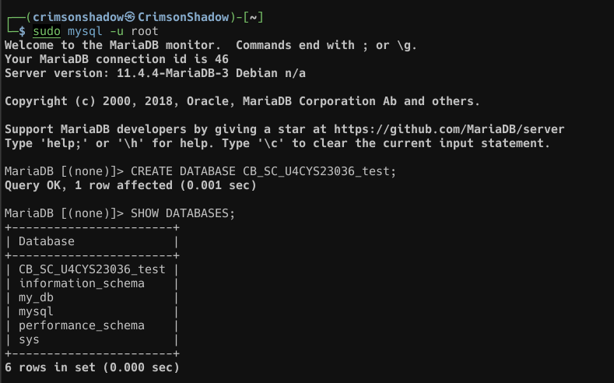

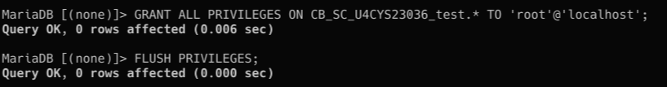

b)

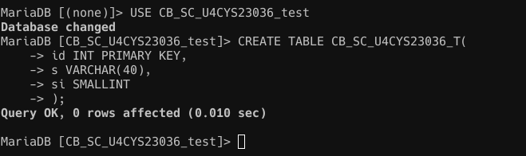

c)

Test with Autocommit On,

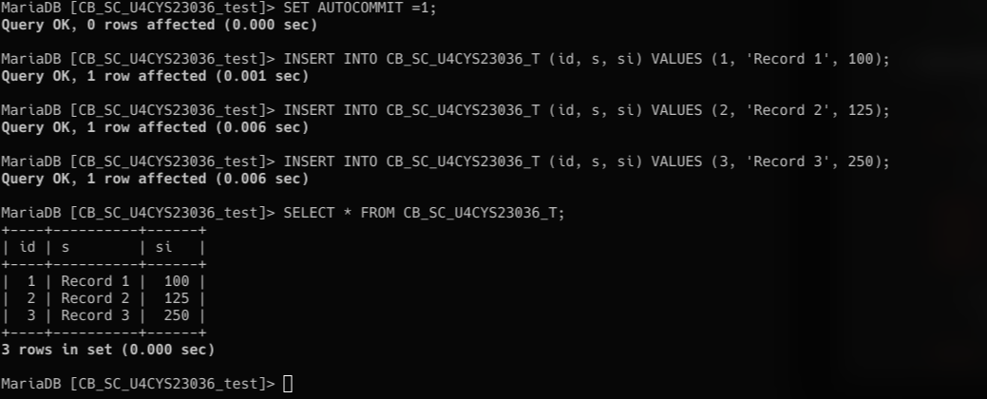

Test with Autocommit Off,

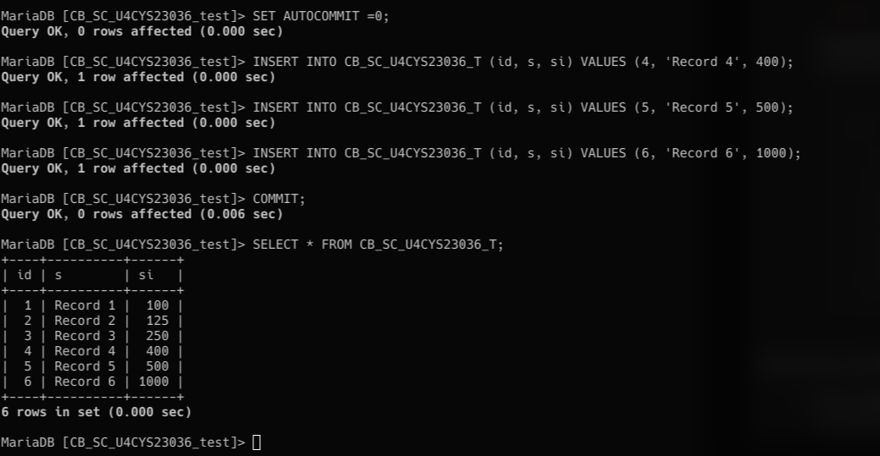

Task 2,

a)

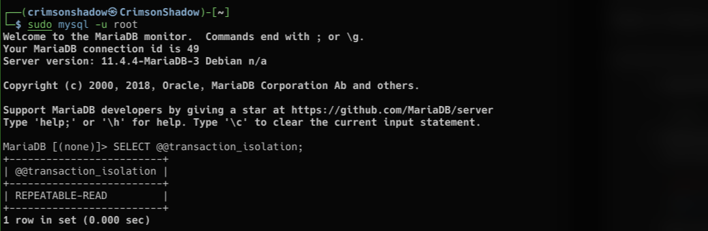

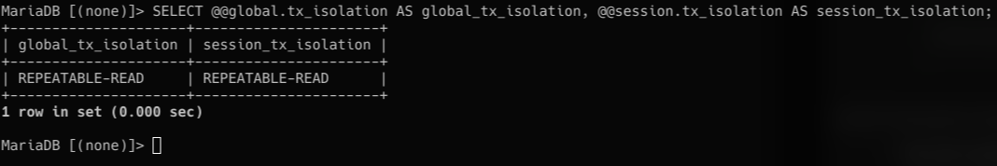

b)

